AI-POWERED MEDICAL LAB REPORT ANALYSIS AND HEALTH INSIGHTS PLATFORM
Block Diagrams (all)
Department of Computer Science and Engineering, TKR College of Engineering and Technology (Autonomous)
Batch A8 (CSE-A) · Academic year 2026-2027
Table 1: Project team
S.No. | Student name | Roll number
1 | BANOTH SWAPNA | 23K91A0528
2 | BEKKAM VARSHITHA | 23K91A0535
3 | A NAVADEEP REDDY | 23K91A0502
4 | BUDIGAM MANOJ | 23K91A0546

Project guide: L.G REDDY
Chapter and section numbers quoted in the text (for example Section 6.6 or Chapter 8) refer to the full project report, 17.Final Document. Figures and tables in this document are numbered from 1.

1. INDEX OF DIAGRAMS
Every diagram is generated from the real design by scripts/make_diagrams.py (matplotlib, 150 dpi) and mirrors the code in backend/main.py, report_processor.py, the four pipeline modules, database.py and models.py.
Table 2: Diagrams in this document
No. | Diagram | Image file
1 | System architecture | docs/diagrams/01_system_architecture.png
2 | High-level workflow | docs/diagrams/02_high_level_workflow.png
3 | Data flow diagram, level 0 | docs/diagrams/03_dfd_level0.png
4 | Data flow diagram, level 1 | docs/diagrams/04_dfd_level1.png
5 | Data flow diagram, level 2 | docs/diagrams/05_dfd_level2.png
6 | UML class diagram | docs/diagrams/06_uml_class_diagram.png
7 | Sequence diagram | docs/diagrams/07_sequence_diagram.png
8 | Use-case diagram | docs/diagrams/08_use_case_diagram.png
9 | Entity-relationship diagram | docs/diagrams/09_er_diagram.png
10 | Flowchart of the core algorithm | docs/diagrams/10_core_algorithm_flowchart.png

2. DIAGRAMS

System architecture
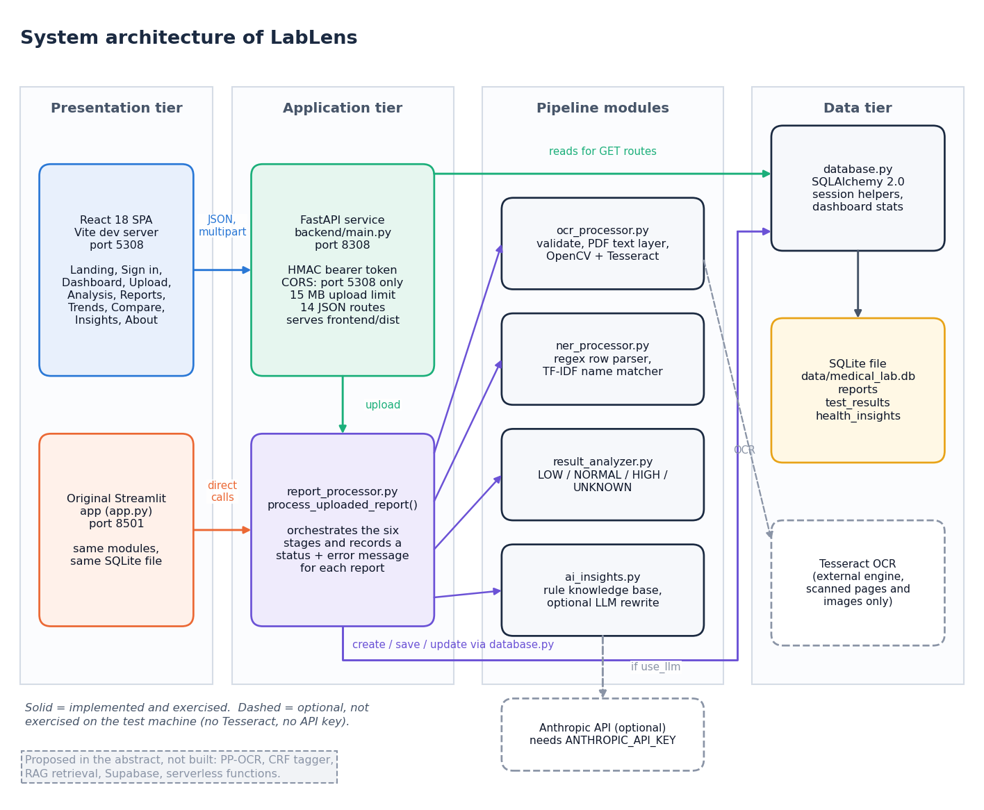
Figure 1: System architecture of LabLens
LabLens has four tiers. In the presentation tier the React single-page application (built with Vite, port 5308) is the main interface, and the original Streamlit application (app.py, port 8501) remains as a second front end that calls the same modules and uses the same SQLite file directly. The application tier holds the FastAPI service in backend/main.py (port 8308), which signs and checks bearer tokens, enforces CORS and the 15 MB upload limit, receives uploads and turns database rows into JSON, and report_processor.py, which coordinates the six pipeline stages and records a status and an error message for each report. The pipeline modules are ocr_processor.py (text extraction), ner_processor.py (row parsing and test-name matching), result_analyzer.py (status rules) and ai_insights.py (explanations). The data tier is the SQLite file data/medical_lab.db, reached through database.py and the ORM classes of models.py. Two services are optional and drawn with dashed outlines: the Tesseract engine, needed only for scanned pages and images, and the Anthropic API, used only to reword explanations; neither was exercised on the test machine. A note on the diagram lists what the abstract proposed but was not built (PP-OCR, a CRF tagger, retrieval, Supabase and serverless functions). After npm run build the API also serves the compiled interface from frontend/dist.

High-level workflow
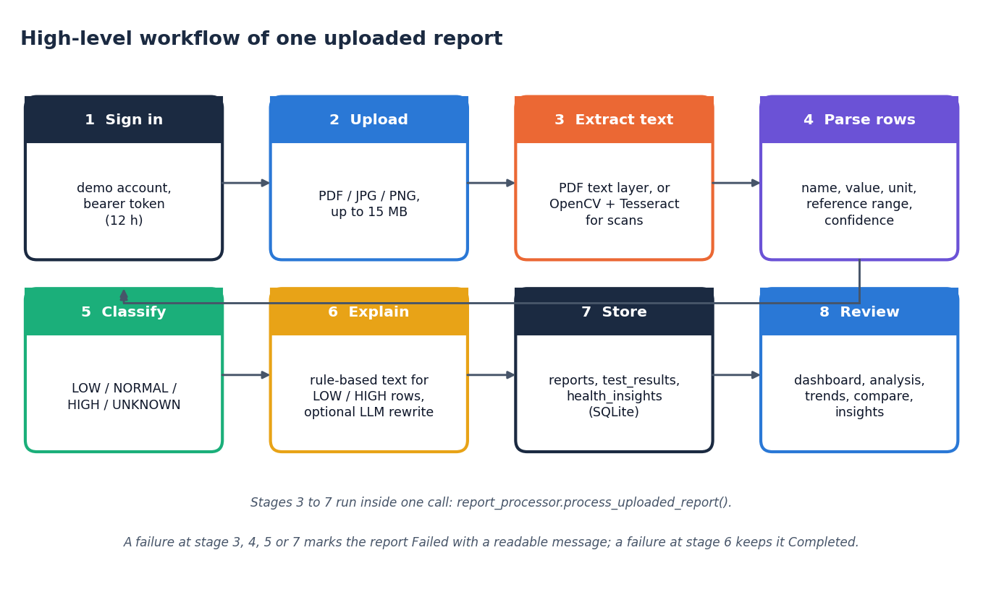
Figure 2: High-level workflow of one report, from upload to review
One report passes through eight steps. The user signs in with the demonstration account (step 1) and uploads a PDF, JPG, JPEG or PNG file of at most 15 MB (step 2). A report row is created at once, so that even a failed upload appears in the report list with its error. Text is then taken from the PDF text layer, or from OpenCV preprocessing followed by Tesseract for scanned pages and images (step 3). The parser turns each line into a candidate row (name, value, unit, reference range, confidence) and snaps the name to a dictionary of 55 test names (step 4). Each row is classified LOW, NORMAL, HIGH or UNKNOWN (step 5), explanations are generated for the LOW and HIGH rows only (step 6), and rows and insights are stored in SQLite (step 7). The user then reviews the results on the dashboard, analysis, trend, comparison and insight screens (step 8). Steps 3 to 7 run inside one call of process_uploaded_report. A failure in the steps that extract, parse, classify or store marks the report Failed with a readable message; a failure in the explanation step leaves the report Completed.

Data flow diagram, level 0
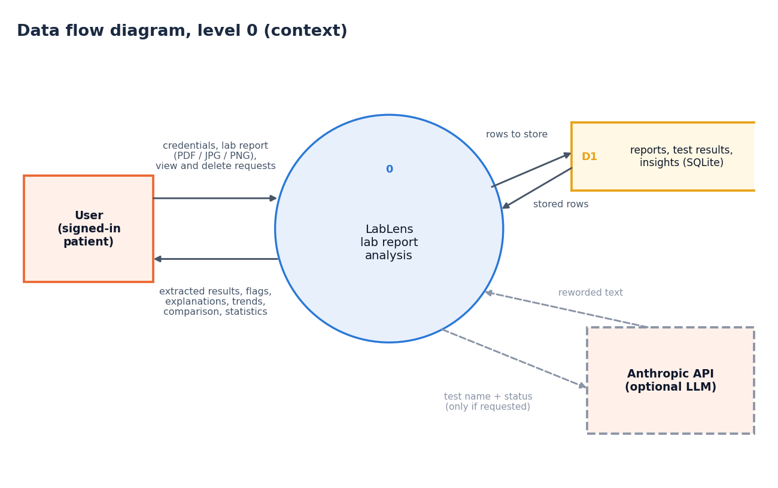
Figure 3: Data flow diagram, level 0 (context diagram)
The context diagram shows LabLens as one process with one external entity, the signed-in user. The user sends credentials, a lab report (PDF, JPG or PNG) and requests to view or delete reports. The system returns the extracted results, their status flags, plain-language explanations, trends, comparisons and statistics. Inside the boundary the process reads and writes one data store, D1, which holds the reports, test results and insights in SQLite. One optional external service, the Anthropic API, receives a test name and status and returns reworded text, but only when the user asks for it and a key is configured. The Tesseract engine is a local program called inside the process and is not drawn at this level.

Data flow diagram, level 1
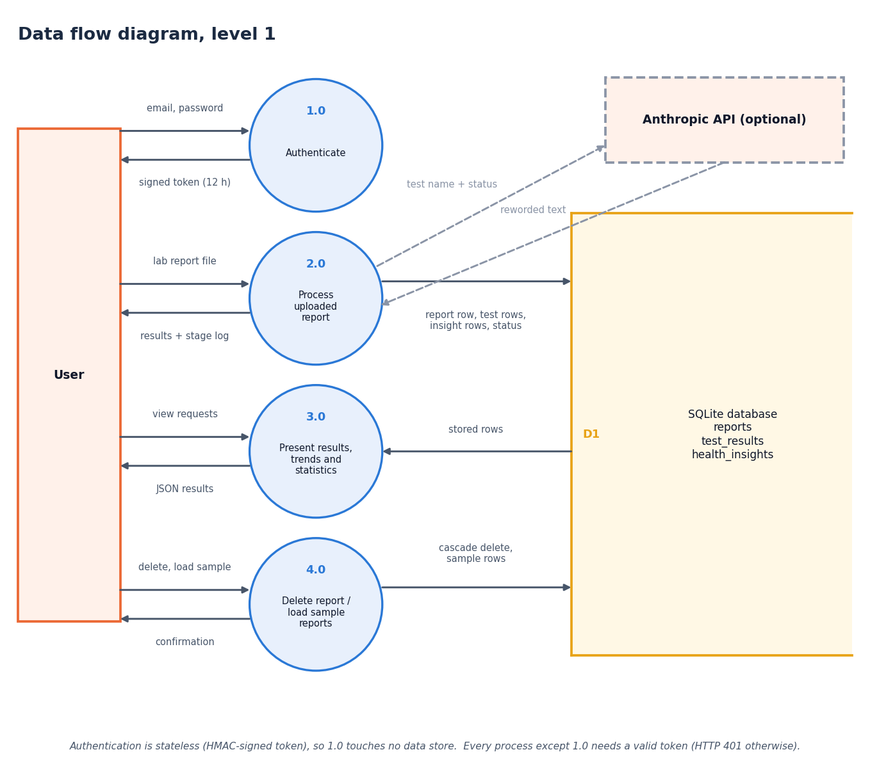
Figure 4: Data flow diagram, level 1
Level 1 splits the system into four processes. Authenticate (1.0) compares the email and password with the configured demonstration account and returns a signed token that is valid for 12 hours. Process uploaded report (2.0) accepts a file and the token, runs the whole pipeline and writes rows to the report, test-result and insight stores (D1, D2, D3); it returns the results and a stage log, and sends a test name and status to the optional Anthropic API only when reworded text was requested. Present results, trends and statistics (3.0) reads the stored rows and returns the dashboard, analysis, trend, comparison and insight data as JSON. Delete or load sample reports (4.0) removes a report with its results and insights by cascade, or adds five synthetic reports. The note under the diagram records that every process except 1.0 needs a valid bearer token and otherwise answers HTTP 401.

Data flow diagram, level 2
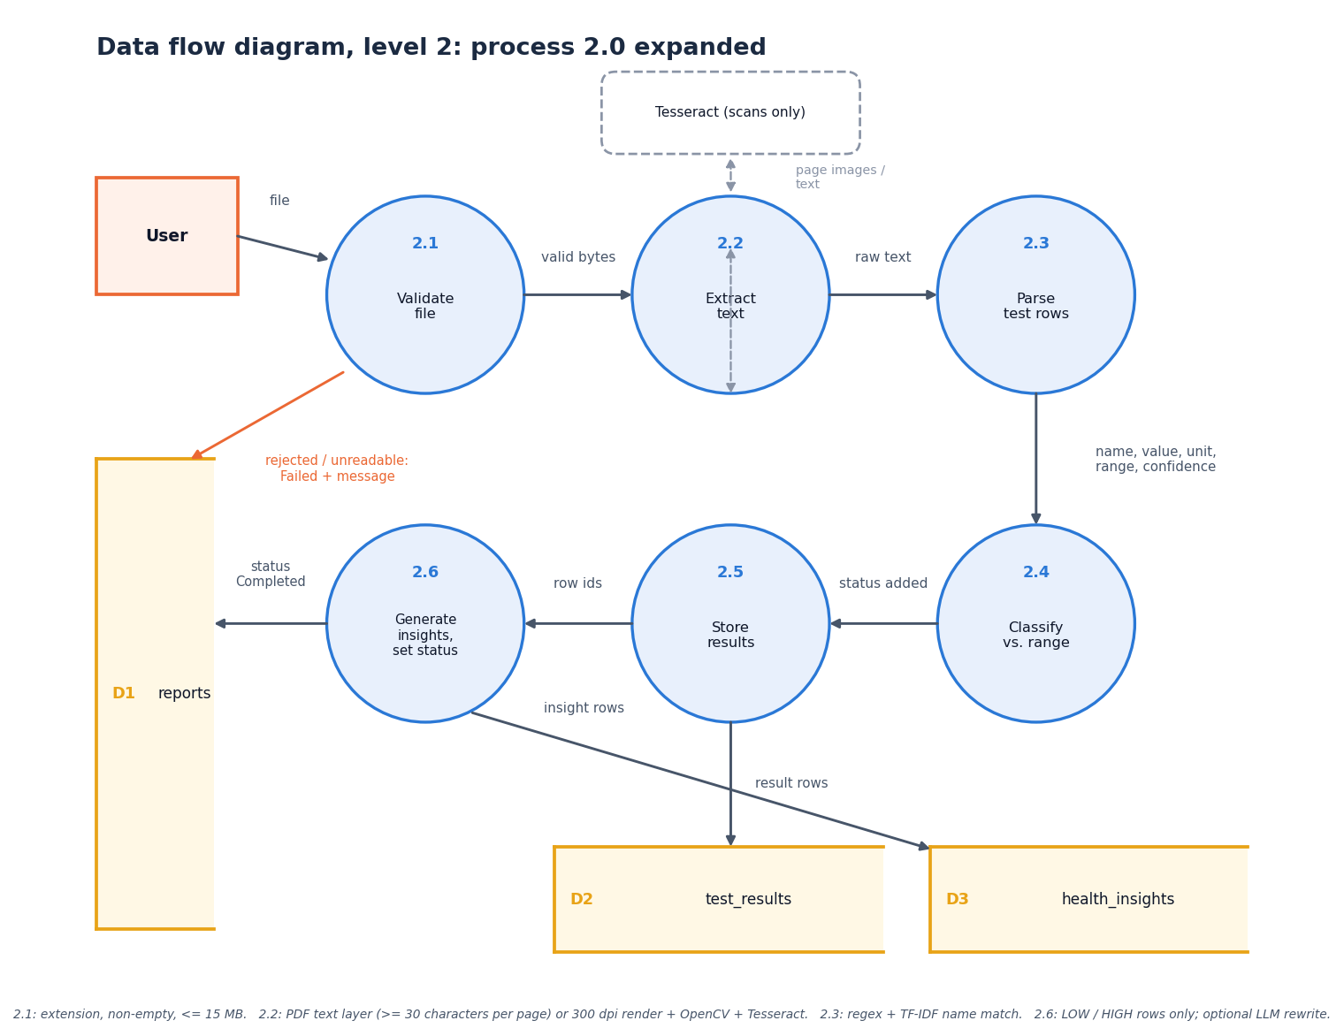
Figure 5: Data flow diagram, level 2: process 2.0 (process uploaded report) expanded
Level 2 expands process 2.0 into the six steps of process_uploaded_report. Validate file (2.1) accepts only pdf, jpg, jpeg and png, a non-empty file and at most 15 MB; a rejected file leads to a Failed report with a message. Extract text (2.2) reads the PDF text layer (at least 30 characters per page) or renders the page at 300 dpi and applies OpenCV preprocessing and Tesseract; an unreadable scan also leads to Failed. Parse test rows (2.3) applies the regular expressions and the TF-IDF name match and yields name, value, unit, range and confidence. Classify against range (2.4) adds the status. Generate insights (2.5) is applied to LOW and HIGH rows only. Store and set status (2.6) writes the result rows (D2), the insight rows (D3) and the report status, raw text and error message (D1).

UML class diagram
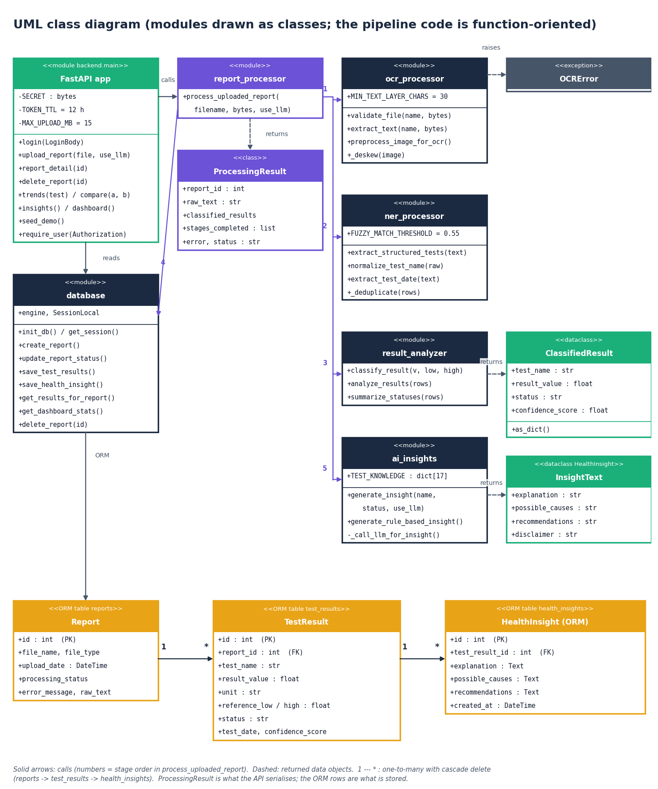
Figure 6: UML class diagram (real classes plus modules drawn as classes)
Most of the pipeline is function-oriented, so the diagram draws each module as a class stereotyped as a module and shows the real classes beside them. The modules are the FastAPI application, report_processor, ocr_processor, ner_processor, result_analyzer, ai_insights and database, each with its constants and public functions. ProcessingResult is the container returned by report_processor; it holds the report identifier, the raw text, the list of classified results, the stages completed, any error and the status. ClassifiedResult is the dataclass returned by result_analyzer. The dataclass HealthInsight of ai_insights.py, which carries the explanation text, is drawn as InsightText so that it is not confused with the ORM class of the same name. The three ORM classes Report, TestResult and HealthInsight (models.py) are linked one to many with cascading delete, and OCRError is the exception raised by the text-extraction stage.

Sequence diagram
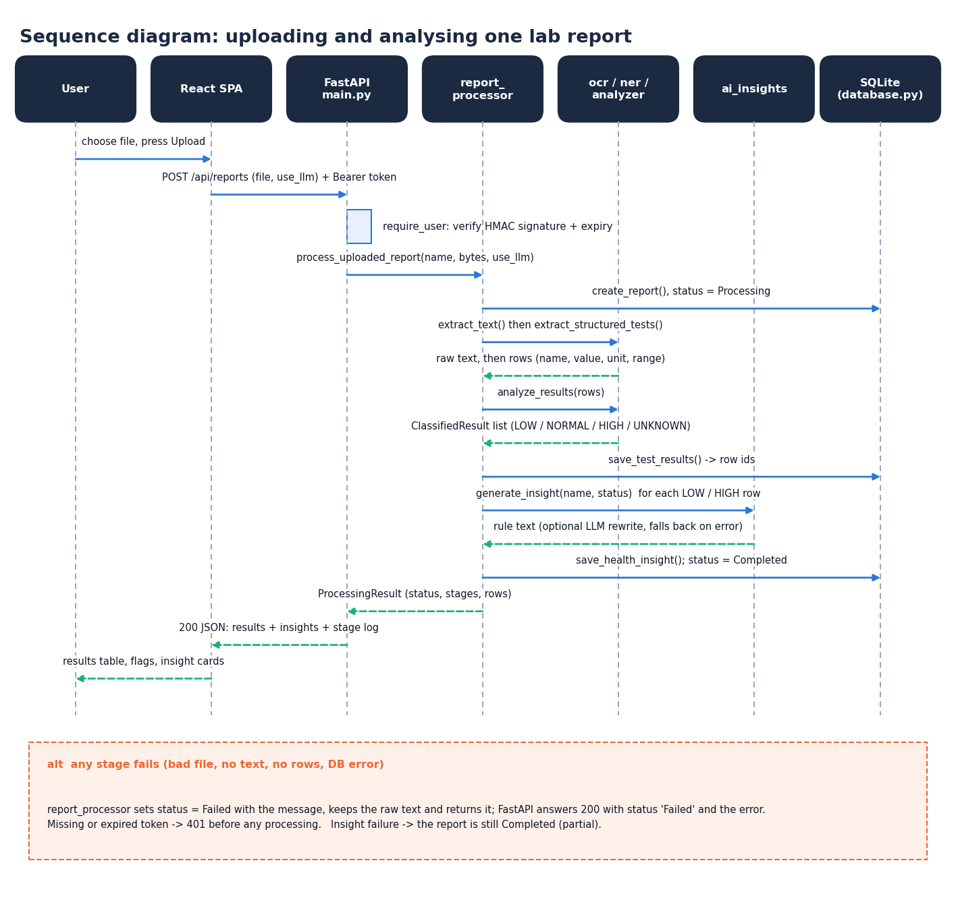
Figure 7: Sequence diagram: uploading and analysing one report
The sequence follows one upload through seven participants. The user chooses a file on the Upload page, which posts it as multipart data to POST /api/reports with the bearer token. The API verifies the HMAC signature and expiry and calls process_uploaded_report, which creates the report row, extracts the text and rows, classifies them, saves them and then asks ai_insights for an explanation of each LOW or HIGH row; the insight is saved and the status becomes Completed. ProcessingResult returns to the API, which answers HTTP 200 with the results, the insights and the stage log, and the page shows the results table, the flags and the insight cards. The alternative box records the failure rules: any failing stage sets the status to Failed with the message and returns it with HTTP 200, a missing or expired token gives 401 before any processing, and an insight failure leaves the report Completed. The whole exchange is one synchronous request.

Use-case diagram
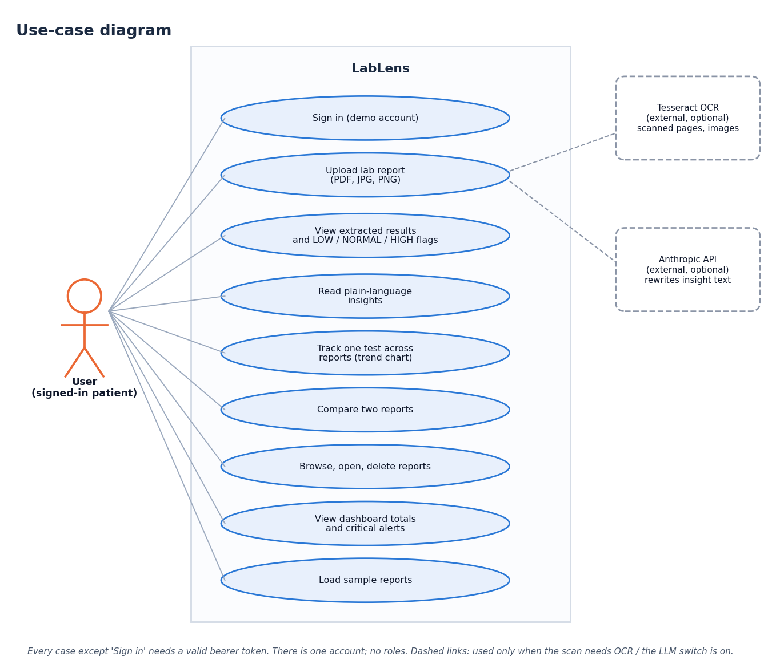
Figure 8: Use-case diagram
There is one actor, the signed-in user, and no roles. The user can sign in with the demonstration account, upload a lab report, view the extracted results with their LOW, NORMAL or HIGH flags, read the plain-language insights, track one test across reports on a trend chart, compare two reports, browse, open and delete reports, view the dashboard totals and critical alerts, and load the five sample reports. Every case except signing in requires a valid token. Two optional external systems appear on the right: the Anthropic API, which extends the insight text when requested, and Tesseract OCR, which the upload case includes for scanned pages and images.

Entity-relationship diagram
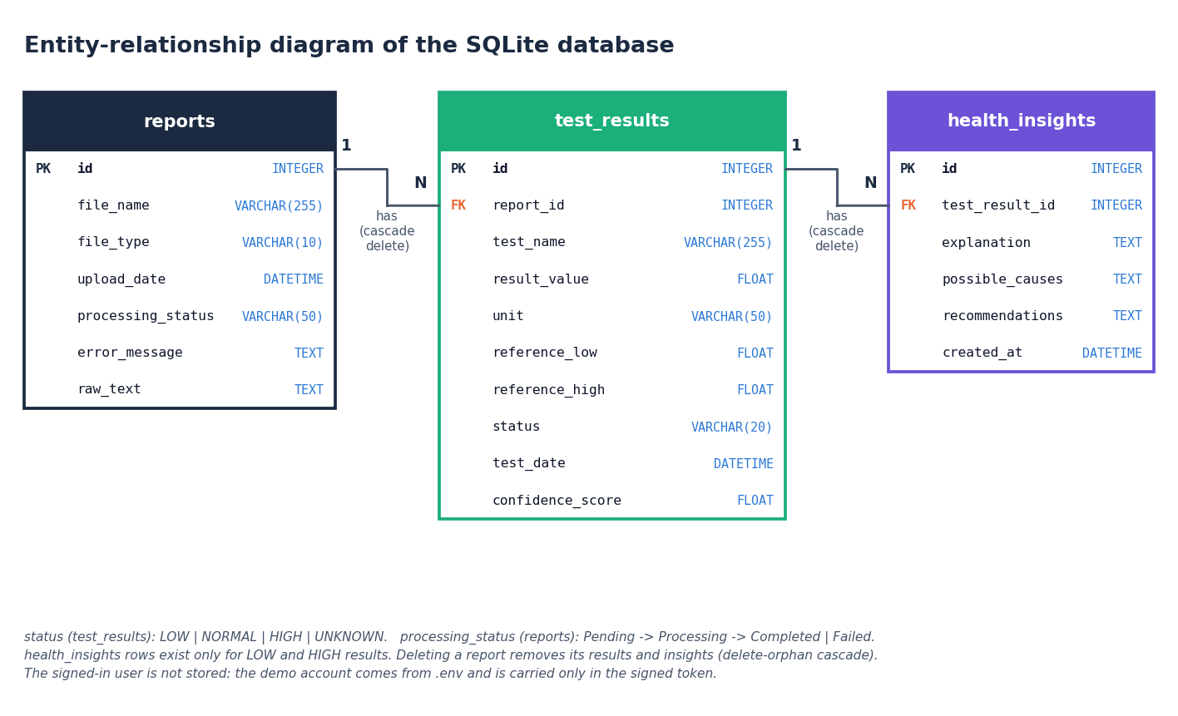
Figure 9: Entity-relationship diagram of the stored data
Persistent data are in three tables. A reports row describes one uploaded file and owns zero or more test_results rows, one for each lab test extracted from it; a test_results row owns zero or more health_insights rows (the code writes one for every LOW or HIGH result). Both relationships are enforced by a foreign key and by the ORM cascade all, delete-orphan, so deleting a report removes its results and their insights. The demo user is not an entity: the account is configured through environment variables and exists only inside the signed token, so the database holds one shared library.

Flowchart of the core algorithm
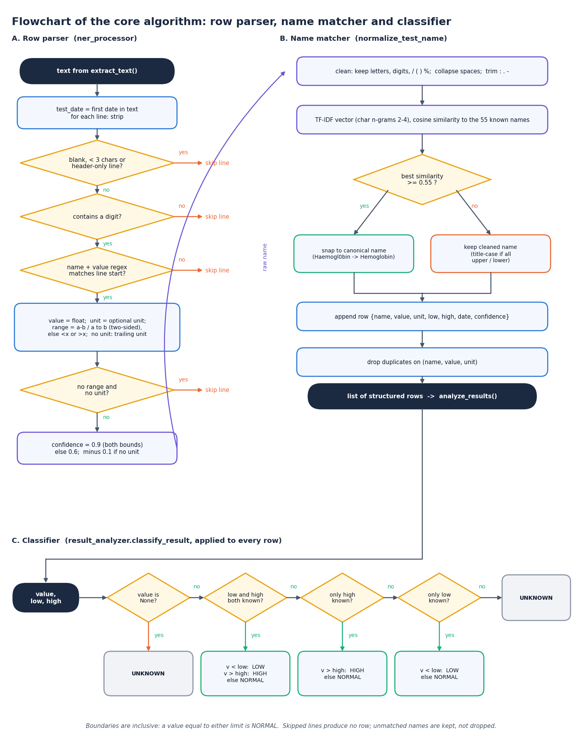
Figure 10: Flowchart of the core algorithm: from a text line to a classified row
The flowchart has three panels that follow the code. Panel A is the row parser of ner_processor.py: the report date is searched once, then each line is skipped if it is blank, shorter than three characters, header-only or without a digit, and must otherwise start with a name followed by a number. The range is searched in the remainder of the line (two-sided first, then one-sided), a unit is taken from the line or from its end, a row with neither range nor unit is skipped, and the others receive a confidence score. Panel B is the name matcher: the name is cleaned, vectorised as character 2-4-grams and compared with the 55 known names; a similarity of at least 0.55 snaps it to the canonical name, otherwise the cleaned name is kept. The row is appended and duplicates on name, value and unit are dropped. Panel C is classify_result: it returns UNKNOWN for a missing value, uses both limits when present, otherwise only the high or only the low limit, and UNKNOWN when there is no limit.

